**Project Description:**

MatchMentor is an innovative web-based application developed by Team RON, designed to bridge the gap between students and qualified tutors across various subjects. The application provides a seamless platform where students can easily search for, connect with, and schedule sessions with tutors who meet their specific academic needs. By offering features like a user-friendly interface, detailed tutor profiles, and integrated scheduling and messaging systems, MatchMentor aims to enhance the learning experience, foster academic growth, and ensure students receive the personalized support they need to succeed in their studies.

**Requirements Summary:**

|  |  |  |
| --- | --- | --- |
| **MINIMUM REQUIREMENTS** | Processor Cores | Dual Core |
| OS | Windows 7 / macOS 10.10 (Yosemite) / Linux |
| RAM | 4 GB |
| **RECOMMENDED REQUIREMENTS** | Processor Cores | Quad Core |
| OS | Windows 10 / macOS 10.14 (Mojave) / Linux |
| RAM | 8 GB |
| **OTHER REQUIREMENTS** | Permissions | Internet Access, Notifications, Storage |

Table 1. System Requirements

To cater to low-end desktop models, the application will have at most a minimum of 2 Cores, 4 GB worth of RAM, and desktop versions windows 7 / macOS 10.10 (Yosemite) / Linux as its OS. The app itself is not at all demanding, hence our team has settled on lower requirement specs.

**Prototype Description:**

The Prototype was created with the use of Figma. This is because Figma is an interactive Prototyping Software/Website that can easily be distributed to testers with the use of links sent by the developers.

**SASHA Figma Link**:

<https://www.figma.com/proto/6IPVVVqojpJqyhG8jPWJgP/MatchMentor-Prototype?node-id=602-1134&t=0WMQici3z7ErHky9-1&scaling=scale-down&content-scaling=fixed&page-id=1669%3A162202>

**User Scenario:**

Tanjiro and Nezuko have been struggling to keep up with their coursework due to a lack of personalized academic support. This issue is affecting their overall school performance. They have difficulty finding reliable tutors and managing their study schedules, leading to poor grades and stress.

One day, Tanjiro discovers an app called MatchMentor, recommended by one of his friends who is excelling in his studies. He installs the app and starts to explore its features. He notices that MatchMentor allows students to easily connect with qualified tutors, schedule tutoring sessions, and track their academic progress. Seeing how this app could address their current problems, Tanjiro shares it with Nezuko. Together, they begin using MatchMentor to find the right tutors and stay on top of their studies, improving their performance and reducing their academic stress.

**MatchMentor Mock-up/Prototype:**

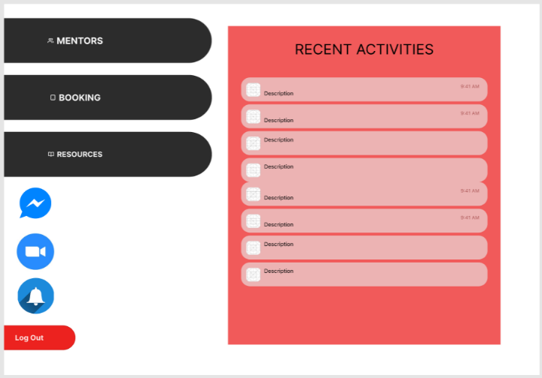

**Student Home Page**

The student home page is where the student user can access the mentor list, bookings, resources, messages, zoom meeting, and notifications.

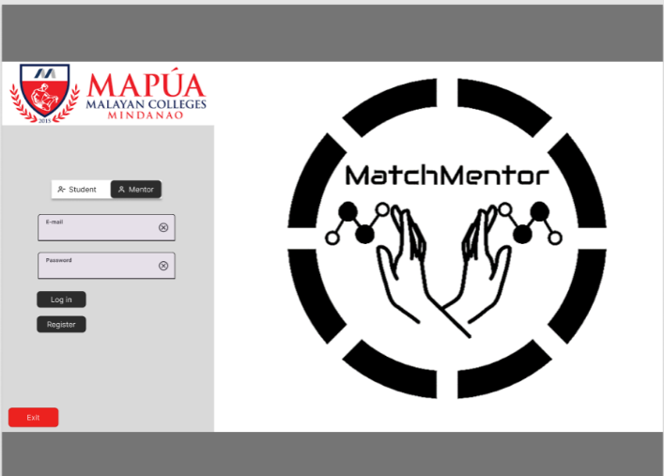

**Log In Page**

The log in Page is where a user can register or log in as a student or a mentor. It has the system logo

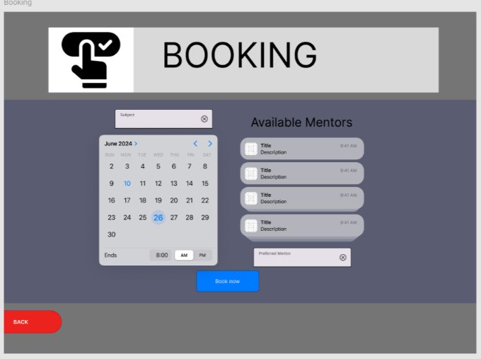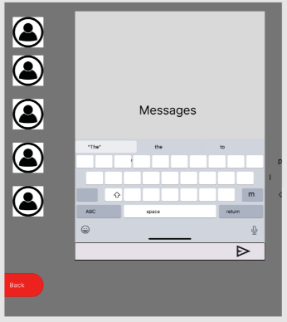

**Booking Page**

The Booking page is where the student user can book the time, date, and the specific subject that the student wants a mentor in.

**Messages Page**

The messages page is where students and mentors can communicate easily.

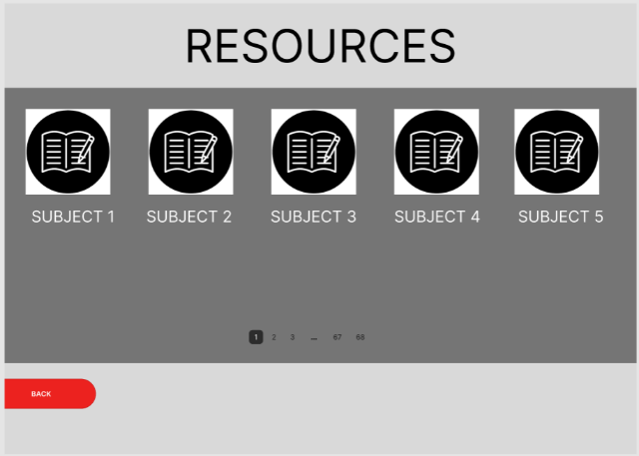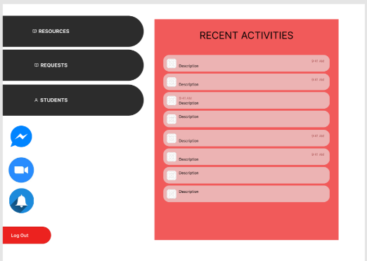

**Resources Page**

The resource page is where students can access learning materials.

**Mentor Home Page**

The mentor home page is where mentors can access their resources, booking requests, and their students. As well as the messages, zoom meetings, and the notifications.

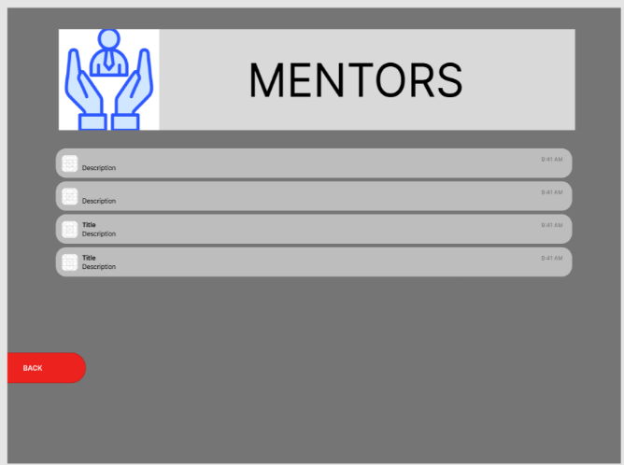

**Mentor List Page**

The Mentor page is the list of the mentors available.

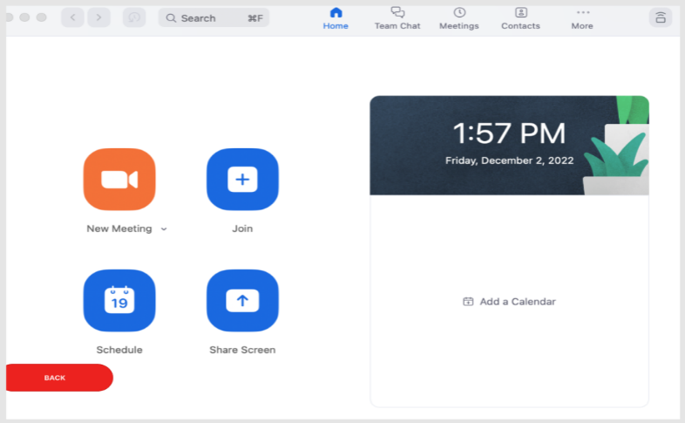

**Zoom Meeting Page**

The zoom meeting page is where the students and mentors can access zoom and its features.

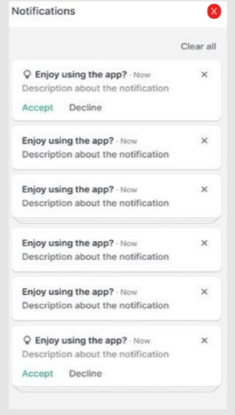

**Notifications Page**

The notifications page is where the students and mentors can be notified.

**Prototype Flow:**

Figure 1 shows how the user uses the app to book a mentor.

**

The student first log ins to access the home page.

Sets the schedule, inputs subject, and chooses mentor.

Presses the Booking Button to open the Booking Page.

This is where the student can see the notifications.

This is the mentors (POV) where he/she will receive a request that the student has booked.

Once the mentor has accepted the request, the student will receive a notification that the mentor has accepted for tutoring.

Here is where the student and mentor will meet in the specified schedule.

**Figure 1**

**Rationale:**

The team has chosen to use Figma for creating the MatchMentor prototype because it is a free, interactive platform that both team members can access to edit the prototype collaboratively. Figma facilitates the showcasing of the final design of the application, making it convenient for presenting and sharing prototypes with users who are not physically present. It also allows for easy modifications based on feedback. However, Figma does require internet access for saving edits, which can be a limitation if the user does not have a stable connection. Additionally, on larger screens, smaller buttons might be challenging to interact with.

**Changes to the Requirements:**

No specific changes were made to the system requirements; however, several changes were made in the usability criteria for the prototype. These revisions aimed to address the question, “How easy can a user use this prototype?”. The revised criteria are based on the 10 Usability Heuristics, which include Minimalist Design, Recognition, Flexibility, Freedom, and Consistency, among others. Furthermore, due to time constraints, the implementation of certain online features was discarded, and thus, the criteria for these features were removed. The primary goal is to keep the prototype as straightforward and user-friendly as possible to avoid confusing users when they transition to the complete version of the prototype.

**Initial Evaluation Plan:**

Due to the ongoing quarantine and remote learning circumstances, the team cannot conduct the evaluation through traditional means. Instead, alternatives like Microsoft Teams and Discord will be used to ensure the team can observe live interactions with the prototype.

The evaluation plan is divided into three parts: Usability Specifications, Heuristics Evaluation, and Participant Survey and Feedback.

**Usability Specifications:**

The creation of this prototype aims to achieve the following measures:

* + **Effectiveness:** Evaluates how well the prototype performs the required tasks.
  + **Efficiency:** Assesses how easy and straightforward the prototype is to use.
  + **Utility:** Ensures the prototype supports appropriate functions and alternatives for certain tasks.
  + **Learnability:** Measures how easy it is for users to learn to use the prototype system.
  + **Memorability:** Assesses how easily users can remember the steps for using the system.

**Heuristic Evaluation:**

The MatchMentor prototype will be evaluated using the 10 Usability Heuristics method:

* + **Visibility of System Status:** The prototype keeps users informed about what is happening.
  + **Match Between System and Real World:** The prototype uses familiar language and follows real-world conventions.
  + **User Control and Freedom:** The prototype provides "Emergency Exit" options to leave unwanted states easily.
  + **Consistency and Standards:** Ensures consistency in the prototype's language and actions.
  + **Error Prevention:** Carefully designed to prevent problems from occurring.
  + **Recognition Rather Than Recall:** Makes objects, actions, and options visible, reducing the user's memory load.
  + **Flexibility and Efficiency of Use:** Caters to both experienced and inexperienced users, allowing them to tailor frequent actions.
  + **Aesthetic and Minimalist Design:** Avoids irrelevant information, focusing on what is necessary.
  + **Help Users Recognize, Diagnose, and Recover from Errors:** Uses plain language for error messages and suggests constructive solutions.
  + **Help** **and** **Documentation**: Provides easily accessible help and documentation.

**Participant Survey and Feedback:**

After conducting the online test, the team will gather data through:

* + **Survey (Quantitative):** Participants will rate their experience with the prototype using a 5-point Likert scale.
  + **Feedback (Qualitative):** Participants will provide detailed feedback on their experience, highlighting any concerns or issues.

These methods will ensure that the prototype meets the usability criteria and is well-received by the target users.